SE420 Laboratory Assignment 7

**Positioning Control of a Motor Using PD, PID, and Hybrid Control**

**Goals for this Lab Assignment:**

1. Design a PD discrete control algorithm to allow the closed-loop combination of a controller and a previously identified plant to meet given specifications.
2. Learn methods to deal with noise and amplifier saturation by modification of the control design.
3. Discover the pros and cons of PD and PID controllers and learn how different design specifications may conflict.
4. Learn how hybrid control methods may alleviate the conflicts between different control methods.

**Matlab Functions Used:**

c2d, d2c

**Prelab:**

Read this entire lab before coming to class so you understand the different controllers to be designed.

**Simulation:**

The intent of this lab is to introduce the student to the design of a discrete control algorithm for the purpose of motor positioning. We will design a discrete Proportional-Derivative (PD) controller that will be implemented on the DC motor. This PD controller will then be modified into a PID and a hybrid control law.

Because we will be doing position control in this lab, we will need the **discrete** transfer function for the angular position of the motor given a voltage input: . In Lab 5, we presented the discrete motor transfer function for velocity given a voltage input:



We cannot attach a z-transformed approximation of an integrator to the system (you must explain why later). Instead, we must transform the  z-transfer function into the s-domain, and then multiply by an integrator in the s-domain. This gives us the correct control-to-position representation in the s-domain. We then transform back into the z-domain to obtain the position z-transfer function  for the motor.

**Problem 1**: *Using the values for  and  that you obtained from Lab 6 for a sample-period of 0.001 second, find the z-transform function, , for your motor. Use MATLAB to help you, using the commands ‘c2d’ and ‘d2c’.*

This lab is the first of the semester where derivative feedback is used. A problem with this type of feedback is that the derivative amplifies signal noise. This is not a problem for your simulation since there is no noise in your simulated signals, but in any actual system you will be controlling (like the motor in lab) there may be a large amount of signal noise. A simple solution is to utilize a filtered form of the derivative, represented in the Laplace domain by the transfer function:



With  very large so the derivative does not roll-off until high frequencies. We will be using a value of . This approach adds a high-frequency roll-off to the derivative action so that instantaneous spikes are attenuated. This should look familiar to you because this transfer function is very similar to the first order filter we experimented with in lab 4 filtering the ADC channels. There is a difference though. Look at the s in the numerator. The job of this transfer function is to find the derivative of the signal applied to the filter when in addition filtering the signal.

**Problem 2:** *Using the "bode" command, compare the bode plots of the true differentiator "s" to this approximate derivative "500s/(s+500)". At what frequency (don't forget units) does this approximation stop comparing well with the true differentiator? For this continuous derivative approximation,  ,to be used in your discrete controller it will need to be discretized. Use the Tustin approximation to find V(z)/P(z).*

In a previous lab, we found that our motor system exhibited nonlinear characteristics due to saturation. Typical controller design tools for linear systems might therefore predict a different system performance than what is measured. This can be a problem for this lab, but we can alleviate the saturation problems by choosing small enough amplitudes of step changes and by using a control approach that avoids large control inputs. In the classical implementation of PID control, the controller is completely in the forward loop as shown in Figure 1 below:



Square Wave

Amplitude: 1 rad.

Period: 2 sec.

**Figure 1: Typical PID control structure**

There are several problems with PID control, some of which we have already seen. In Lab 7, we encountered problems with the integral term, and some of the goals of Lab 7 were to find solutions specifically to the integral-windup issue. When we consider adding a derivative term, an additional problem arises apart from noise. To see this problem, let us assume that we wish to analyze the controller performance using step inputs or square waves. For these signals, the derivative term becomes infinite for an infinitesimally short time. Even with a filtered derivative described above, the magnitude of the jump will cause a very large control signal to be sent to the plant for a short period.

The signal discontinuity of a step change generally isn’t a problem in the continuous domain, but in the discrete domain the smallest time interval is determined by the sampling period. If the derivative term is very large for one sample period, and if one sample period is a large portion of the rise time, then the derivative term may contain a large portion of the control effort needed to move the motor from one position to another. With saturation, much of this control effort may be removed. If we design a controller with classical control techniques, the design will produce the expected result on the linear plant, but not on the nonlinear system with the saturated input. The amount of control signal ‘lost’ during the saturation of the derivative is simply too high to adequately design the controller in our case.

If we think about the derivative term, it is present to prevent excessive velocity of the motor’s motion. It is common practice to feedback the velocity of the motor directly, rather than use the derivative of the error. This produces a control structure with control elements present in both the forward and in the back portions of the feedback loop, shown in Figure 2 below:



Square Wave

Amplitude: 1 rad.

Period: 2 sec.

**Figure 2: A PD controller with control components in the forward and back loops.**

Compare this to the classical loop in Figure 3.



Square Wave

Amplitude: 1 rad.

Period: 2 sec.

**Figure 3: A PD controller with control components only in the forward loop (classical form).**

**Problem 3**: *Using continuous-domain representation of the components (transfer functions in the Laplace operator ‘s’), derive the closed-loop transfer functions for the two PD controllers of Figure 2 and Figure 3. Use variables to represent the P-gain, D-gain, motor gain, and motor time constant (Kp, Kd, Km, and Tm respectively in above Figs.). Use just “s” for du/dt. Do they have the same poles? Do they have the same zeros?*

As an initial exercise we will design a PD controller of the type shown in Figure 2. Our design method we will be to use root locus techniques to find the Kp gain while iteratively changing Kd until a good set of gains is found. We will be using the function “rltool” to perform this design. Launch **rltool** from the Matlab command prompt with the command “rltool(*your discrete motor transfer function)*”. A graphical user interface will load showing a window that looks like Figure 4. First change a preference in **rltool** telling it how to display the transfer functions you add to your controller. Select the “Preferences” button. Under the “Options” tab select the radio button “Zero/pole/gain” in the “Compensator Format” section and click “OK”. Next you will need to tell **rltool** what type of block diagram your design will use. Click the “Edit Architecture” button and another window will appear. Select the architecture that has both the C1 and C2 control blocks. C1 has the error as its input and C2 has the motor’s position as its input. (See Figure 4). In our case C1 is just our Kp gain. C2 is the portion of the controller’s transfer function in the feedback path. In our case this is the discrete representation of the transfer function Kd*500s/(s+500). The input to G (the plant) is C1 – C2. C1 can just start out at 1. Double click on C2 in the “Controllers and Fixed Blocks” section and enter C2’s poles, zeros and gain by right clicking in the “Dynamics” white space. Then in the root locus plot you can click on your pole locations (pink squares) and drag them to a desired location. C1’s gain changes when you drag the poles to a new location. By default the r2y (reference to Y output) step response is displayed. Another useful plot is the control effort step response r2u. Right click in the “Responses” section on the “IOTransfer_r2u” item and select Plot->Step.

For the design, we will have to decide on an initial derivative gain Kd. Next, we will use **rltool** to adjust Kp (i.e. C1’s gain) to see if the design specifications can be met. Depending on the results, we may need to repeat the process, increasing or decreasing our initial Kd value as needed.

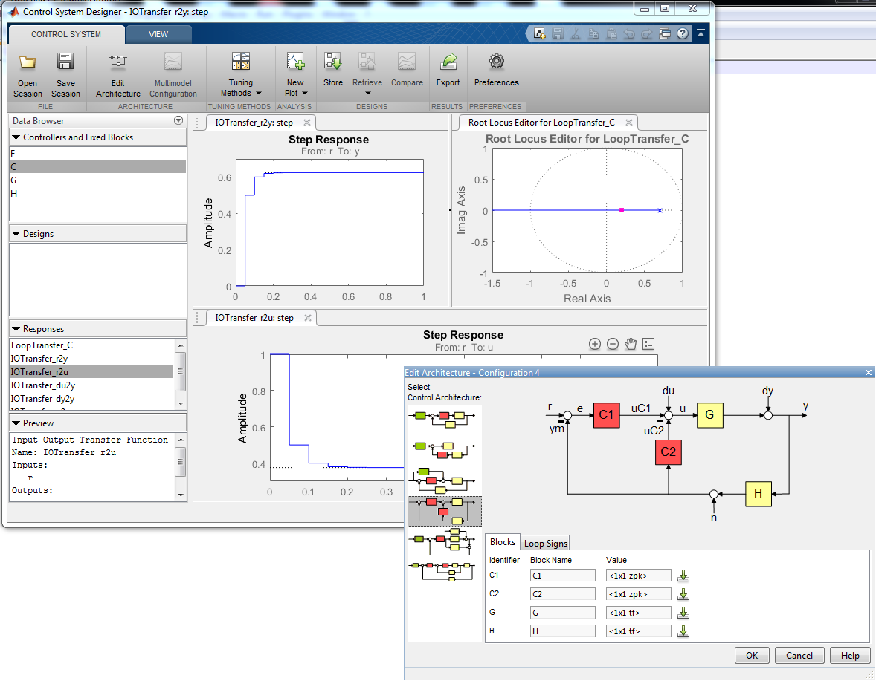

**Figure 4: The SISO Design Tool Matlab Command “rltool”**

**Problem 4**: *Using the discrete plant representation for motor position control from problem 1 and the Tustin derivative approximation from Problem 2, use “rltool” to design your controller. Initially pick a starting derivative gain, Kd, value at some ‘guess’ (less than 10), and use “rltool” to find a Kp-gain such the following design specifications are be met:*

* + 1. *Less than 1% overshoot for a step or square-wave input*
    2. *Rise time greater than 150 ms and less than 300 ms*

*If the derivative gain you selected does not allow the specifications to be met, change the Kd-gain and iterate your PD controller design until the specifications are met. Simulate your controller in SIMULINK in the discrete domain, and verify that the design specifications for tracking of 1 radian amplitude square wave. Are the specifications met if you limit the control effort with a saturation term to be within +/- 10 units?*

**Laboratory Exercise**

**Note:** For this lab we will not be using the friction compensation we found in lab 7.

**PD Control**

1. Implement the controller you just designed in rltool and simulated in Simulink on the actual motor and compare simulated data to actual data. Use “matlab/simulink5ms_plotAndGains.slx” to plot the motor’s position and control effort applied to the motor. Use a reference square-wave of amplitude 1 radian with a period of 2 seconds. Experiment with the Kp and Kd gains to get a feel of how each gain changes the systems response. Show your controller to your TA and answer question 2 of the lab check-off.

**PID Control**

1. Add an integral error term as you did with your velocity controller in Lab 7 (use the Tustin approximation to implement the integral). Also add code to prevent integral windup. Use the Expressions Window in Code Composer Studio to modify and tune Kp, Ki, and Kd gains and additionally your reference square-wave amplitude.
2. Again experiment with the Kp, Kd and Ki gains to get a feel on how each effects the system response. With a Ki gain of 100, try to tune the Kp, Kd gains to eliminate steady-state error within 0.5 seconds of the step change. Do question 3 of the lab check-off.
3. How to design PI plus velocity feedback controller in rltool. First show that the PI controller transfer function emulated with the Tustin rule can be written in the form $K_{Loop}*\frac{z-{zero}_{c}}{z-1}$, with $K_{Loop}=\frac{2*Kp+Ki*T}{2}$ and ${zero}_{c}=-(\frac{Ki*T-2*Kp}{2*Kp+Ki*T})$. KLoop and zeroc are the design values you can tune in rltool to design the PI portion of the controller. Take the values you found for Kp and Ki and add the PID control to your rltool design of your PD (Proportional plus velocity feedback) controller and show that it has a similar response to your motor’s actual response.

**Hybrid Control**

The previous PID controller implementation shows that the PID and the PD have conflicting effects on the tracking performance. One method to gain the advantages of each control method is to use a ‘hybrid’ or ‘switching’ controller. A hybrid controller has a very specific mathematical definition, but for purposes of this lab we may think of hybrid control as simply switching between different control methods to gain the advantages of both. We will demonstrate this by switching between PD and PID control of the motor. Obviously, hybrid control is especially concerned with the switching conditions. In this lab we will measure how fast the tracking error is changing, or the time-derivative of our error, and use this to define a switching condition.

1. Modify your code to run two controllers: one PD lower gains and one PID higher gains.
   1. The PD lower gain controller should be switched on when the magnitude of the derivative of the tracking error is higher than or equal to some switch point. We will make this ‘switch-point’ a gain you will tune. The derivative term in the PD controller will still be the derivative of the motor position as you did in simulation, but the switching condition depends on the derivative of the tracking error. Find the derivative of the tracking error with the same derivative approximation of 500s/(s+500) emulated with the Tustin rule.
   2. The “PID high gain” controller should be switched on when the magnitude of the error-dot term is less than the switch point. You will find the controller runs best if the integral-sum is zeroed each time the PD controller is switched on. DO NOT integrate the error when the PD lower gain controller is running.
2. While attempting to track the square-wave from before, tune your Kp, Ki, Kd, square-wave amplitude, and switch-point values to satisfy the following conditions for tracking a 1 radian amplitude square wave:
   1. No steady-state error after 400 ms of any change in reference position.
   2. Rise time in the range 150ms < tr < 200ms.
   3. Ki gain greater than 500. This will make the system robust to disturbances. Of course the disturbances can’t be too large because we are dealing with a small motor.
   4. Overshoot less than 1.5%
3. Make a plot of your controller for check-off.
4. Do question 4 of the lab check-off.

**Lab Check Off:**

1. Demo your simulation.
2. Demo your PD controller implemented on the DSP/motor system. How did your simulation results compare to implementation results (see questions from Exercise 1)? You should have two plots (or better, one with both data sets plotted) to show to your TA to compare: one simulation, one implementation. How do they compare? Do you see overshoot? The same rise time? Do you see significant saturation in the control effort? Do you observe any steady-state error?
3. Demo your PID controller to your TA. Is it possible to have an aggressive Ki gain (greater than 100) yet still achieve zero overshoot? What is the percent overshoot when you apply a 6 radian amplitude square wave? 12 radian amplitude? 18 radian amplitude?
4. Demo your Hybrid controller. What is the Hybrid controller’s percent overshoot when you apply a 6 radian amplitude square wave? 12 radian amplitude? 18 radian amplitude? How is the hybrid control better than PD? To answer this question, consider the following: How is the Hybrid controller better than the PID control when tracking different amplitude square waves (look at overshoot, settle time, rise time, etc)? Are the gains of your Hybrid controller higher or lower than the PID control? What happens if you tune your Ki gain too high? What happens if you choose your switch-point too high? Too low?