ME 446 Final Project
Lab sessions will be held the weeks of
April 15th, April 22nd, April 29th
Demonstration Day Tuesday May 7th from 7:00 to 10:00PM. We will be posting a sign-up sheet for a demonstration time slot.

Objectives
- Perform all steps of the contest given below.

Steps to complete during demonstration run.

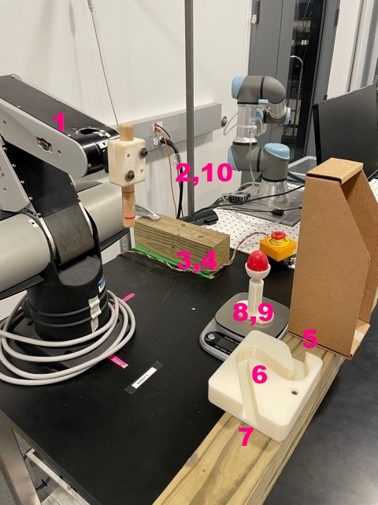
- General guidelines
  - The starting position for the robot is at its resting position. Make sure to have all your variables, like the previous angle states, start at these initial conditions. This will minimize the robot jumping when it first starts.
  - Once your robot starts moving the timing clock will begin. You will want to minimize the time it takes your robot to complete the steps.
  - Once the robot arm finishes the entire trajectory and stops at (x,y,z)=(10,0,20)in., the timing clock will stop. The time of the clock will be your run time for that run.
  - Fastest time wins the contest but smart looking trajectories and careful movements score higher when it comes to your grade for the final project. The majority of the points for the final project are for completing these given steps, but there will 10 points under the discretion of the instructors for a well programmed robot.
- Path details
  - Point 1-2: Move your robot in a straight line to a position of your choice from its resting position.
  - Point 2-3: Using a number of straight line trajectories, move the robot’s peg just above the hole that is directly to the left of the robot.
  - Point 3-4: Insert the robot’s peg into the hole so that the peg is inserted two inches. A red line on the peg that indicates the needed depth. You must stay in the hole for at least 0.5 seconds so that we can measure if the peg went deep enough into the hole. Then have the robot pull its peg out of the hole.
  - Point 4-5: Use a number of straight line trajectories to avoid the obstacles in the robot’s path and bring the peg to the entrance of the zig-zag. The entrance is on the robot’s left.
  - Point 5-7: Navigate the peg through the zig zag. Here you may want to rotate your end effector coordinate frame about Z so that you can weaken your Kp and Kd gains perpendicular to lines through the zig zag. There is another red line on the peg that indicates the depth the peg needs to be inside the zig zag. It is around 20 mm or so. You also must enter the zig zag and exit the zig zag. You cannot bring the peg down into the zig zag nor can you raise the peg before the peg has fully exited the zig zag.
  - Point 7-8: After exiting the zig zag, use a number of straight line trajectories to bring the peg just above the egg.
  - Point 8-9: Once above the egg, push down on the egg with the peg so that the scale reads in the range 500 to 1000 grams. You must press down on the egg in that force range for two seconds.
  - Point 9-10: Once two seconds have elapsed, gently remove force from the egg and then use some straight line trajectories to move the robot arm to its theta1motor = 0, theta2motor=0, theta3motor=0 position, corresponding to (x,y,z)=(10,0,20)in.

Report:

You will need to put your completed C file at your Box folder. You should comment your code explaining the methods you used to complete all the desired steps/tasks. Your comments will be graded to see if you understood the code developed. Comments should be paragraphs not just short bullet comments. Also take a video or two of your robot working through the steps and them in your Box folder. Submit your commented code by May12th.

