LABVIEW Assignment #1, due before Thursday February 1st at 5:00pm. Simply demonstrate your five LABVIEW programs working. Grading for this assignment is simply full credit if you did the assignment and no credit if you did not complete the assignment. Make sure to ask questions if you get stuck.

Read through at least the first two sections at the site http://www.ni.com/gettingstarted/labviewbasics
LABVIEW Environment Basics and Dataflow Programming Basics
And Watch at least the first two videos and the tenth video at the site https://www.youtube.com/playlist?list=PLB968815D7BB78F9C

- Then reproduce (does not have to be exactly the same) the Fahrenheit to Celsius LABVIEW program that uses a loop structure to continuously run until a Stop button is pressed. Add some bells and whistles if you would like.
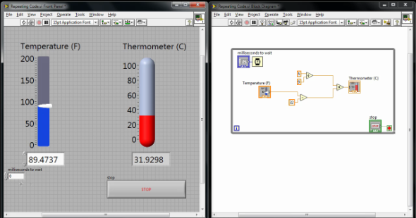

Read through all 12 sections at the site http://www.ni.com/gettingstarted/labviewbasics
And watch the first 10 videos at the site
https://www.youtube.com/playlist?list=PLB968815D7BB78F9C

You can find other good Youtube videos. Here are a few others I found to get you started
https://www.youtube.com/watch?v=Em5R_RM8E08
https://www.youtube.com/watch?v=bflByHG5jdc
https://www.youtube.com/watch?v=0Ea2IQeCIMY
https://www.youtube.com/watch?v=QxoJljThkKk

And watch the below youtube video that introduces sequence structures
https://www.youtube.com/watch?v=DjN5Fpsjwng
- To give you an introduction to sequence structures, reproduce the VI demonstrated in the youtube video https://www.youtube.com/watch?v=03PykG1O1x0 . You may need to find some online help on “Case structures” as they are used in this video but not explained.

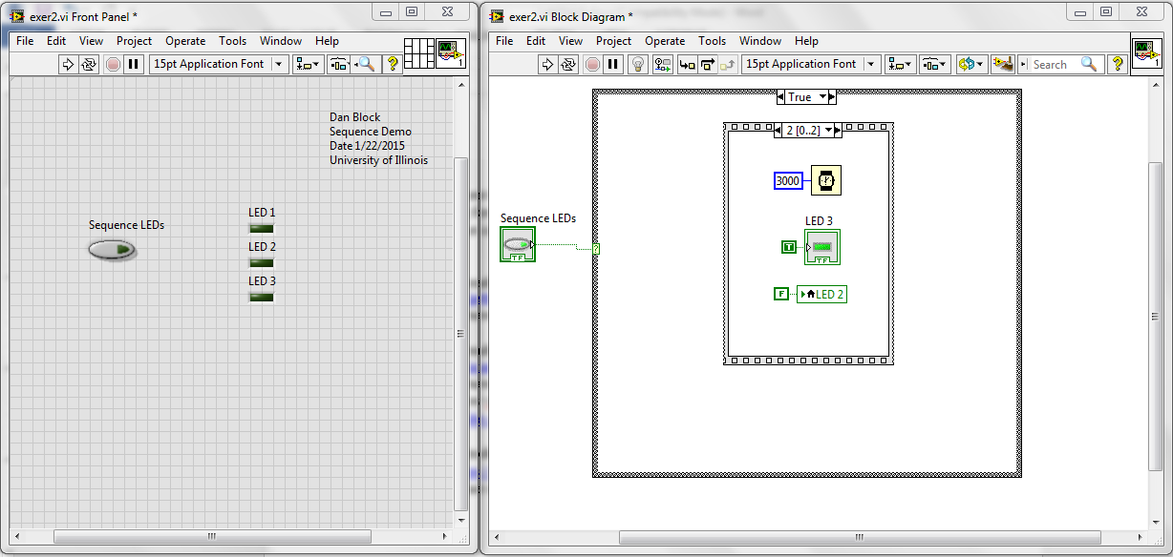
- To give you an introduction to event structures, reproduce the VI demonstrated in the youtube video https://www.youtube.com/watch?v=8eO64fo3Pho . You do not need to demonstrate the initial “polling” VI. Just the event structure VI.
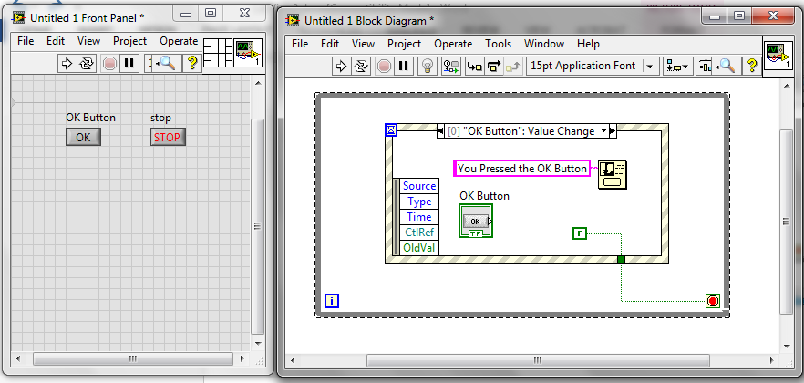

Read through the Array and Clusters Tutorial at https://www.youtube.com/watch?v=rzOT1zXBDiE and
https://www.youtube.com/watch?v=_GlQ1riWjPc&list=PLB968815D7BB78F9C&index=8

- Then reproduce the following exercises:
See how a “for loop” can create a multidimensional array and use the Index Array to pull out a single row and single column and a single element. Sine is found under Mathematics->Elementary->Trig
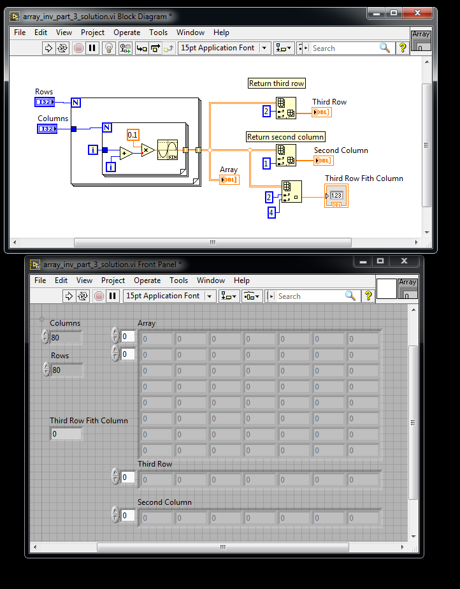

- Create a Cluster and then produce two Clusters similar to the first.
