**SE 423 Mechatronics Homework Assignment #1**

**Spring 2024, Due In Lecture Wednesday January 31st. The Code/Board Demonstration Check-Offs for Questions 5, 7, 8, 9 and 10 are due by 5PM Tuesday January 30th.**

1. For this exercise, I would like you to go through the “C Essentials Training” course at [https://www.linkedin.com/learning/c-essential-training](https://www.linkedin.com/learning/c-essential-training/plunging-into-c?autoAdvance=true&autoSkip=false&autoplay=true&resume=true) (You first need to login through the UIUC LinkedIn Learning portal with your university NetID to get past the paywall : <https://web.uillinois.edu/linkedinlearning> ). I am not going to check if you went through every exercise, but I highly recommend it. Go through each chapter. Then for your Homework submission, submit your code and any screen shots showing the code working for
   1. Chapter 3’s final challenge, Binary Math
   2. Chapter 4’s final challenge, The Grid Challenge
   3. Chapter 5’s final challenge, Complete the Code

Yes I know the solution code is given to you in the course’s download file. Try your best to not look at the solutions, as that will help you teach yourself C. DO NOT just submit the solution code! The areas I want you to really think about as you are going through this training are: The different types of variable in C and how to declare global and local variables. The printf statement and how to use it to print integer variables and floating point variables. Writing functions and how to call those functions in your C code.

There are quite a number of free C compilers that you can use to run the C code you write for these training exercises. I am thinking using one of the online C compilers may be the easiest way to go. You can google search for “online C compilers” and see which one you like or you can try this one that seems to work pretty well [https://www.onlinegdb.com/online_c_compiler#](https://www.onlinegdb.com/online_c_compiler) I think the biggest issue you will have with the online compilers is saving your files. So I recommend cutting and pasting your code into any text editor and save your work with the text editor instead of saving from the online webpage.

1. Solder your breakout board. (When in doubt, view the demo board in lab.) In previous semesters a TA made some recordings as he was soldering a board very similar to your breakout board. On the board he is soldering you will see more parts than you have to solder. Keep that in mind when you are watching these videos and use them as a guide not the exact way you need to solder this board. <https://www.youtube.com/playlist?list=PL-csvMdAo235aAa4sEBl57S_syIAsQHoW>
   1. Solder the four 2X10 gold plated headers. !!Show your instructor that you have them in the correct orientation before soldering!!
   2. Solder 18 1Kohm resistors along with 18 surface mount LEDs. !!Make sure you know the orientation of the LEDs!!
   3. Solder 3 74LVC04 surface mount inverter chips. Also 3 0.1uF capacitors right next to these chips.
   4. Solder 4 pushbuttons.
   5. Solder 1 buzzer, orientation does not matter, and one 100ohm resistor next to the buzzer.
   6. Solder one 2X2 header which controls the input to the buzzer. Make sure it is in the center holes.

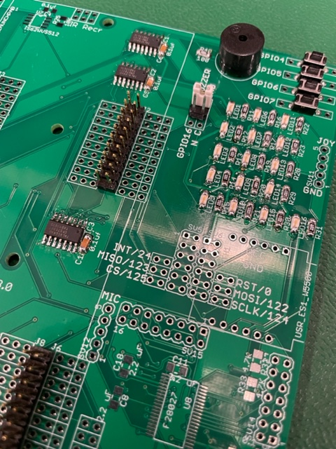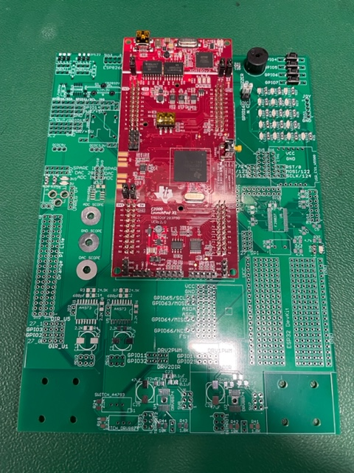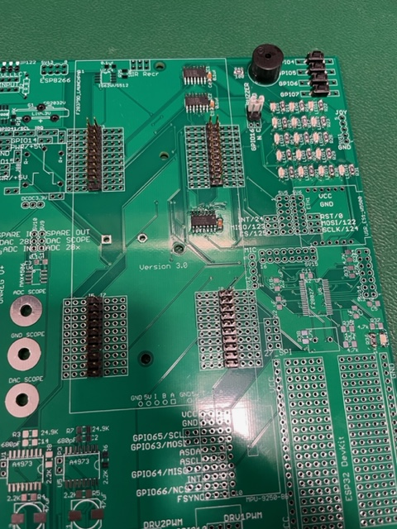

1. Create you Home Work Repository
   1. Follow the document [Using the SE423 Repository](http://coecsl.ece.illinois.edu/se423/Using%20the%20SE423%20Repository.pdf) and its first section “Create your Repository” to check out the SE423 repository to your lab PC and/or your personal laptop. If you are going to be using both the lab PC and your laptop for development you will want to create the same path on both your laptop as on the lab PC. Create a folder with its name your NetID at the root C:\ drive and keep all your files there. It is also a good idea for you to make backups of your lab files outside of your Git repository as you progress through the semester. Making this extra backup will save you when we can’t figure out what went wrong with Git. Git is awesome and normally works great but every once in a while I have seen issues that caused students to lose versions of their files.
   2. Open Code Composer Studio 12 (CCS 12) and select the “workspace” folder in your repository. For example, if your netID was “superstdnt”, you would have checked out your repository in c:\superstdnt\SE423_repo. The workspace folder then to select would be c:\superstdnt\SE423_repo\workspace.
   3. Once CCS 12 is done loading your workspace, you need to load the “HWstarter” project. When you perform this load, the project is copied into your workspace. Therefore, if you rename this project, you will be able to load the “HWstarter” project again if you would like to start another minimal project. I purposely located this “HWstarter” project in the same folder that has many of the example projects you will be studying this semester. These examples are part of the software development stack that TI calls C2000ware. I have copied the needed parts of C2000ware into our repository so that if you accidently modify something you can easily get it back. Again now if your NetID was “superstdnt”, perform the following to load your starter project. In CCS select the menu Project->Import CCS Projects. Click “Browse” and explore to “C:\superstdnt\LabRepo\C2000Ware_4_01_00_00\device_support\f2837xd\examples\cpu1\HWstarter” and finally press “Finish”. Your project should then be loaded into the CCS environment. Let’s then rename the project “HW1<yourinitials>” by right clicking on the project name “HWstarter”. In the dialog box change the name to “HW1<yourinitials>” i.e. HW1djb. Also explore into the project and find the file “HWstarter_main.c”. Right-Click on “HWstarter_main.c” and select “Rename”. Change the name to “HW1<yourinitials>_main.c”. To save you some headaches in the future, I recommend you perform one more step after you have created a new “HWstarter” project. Right click on your project name in the Project Explorer and select “Properties.” Select “General” on the left hand side. Then in the “Project” tab find the “Connection” drop down and select “Texas Instruments XDS100v2 USB Debug Probe.” “Apply and Close”.
   4. Now that you have the project loaded you can build the code and download it to the LaunchPad board. Plug in your LaunchPad to the USB of your PC and then in CCS hit the green “Debug” button  and in the dialog box the pops up, select CPU1 only. This will compile the code and load it to your LaunchPad board.
   5. Click the Suspend button  to pause the code and the Resume (or Play) button  to resume or start your code’s execution Use both of these to prove to yourself that both the blue and red LEDs are blinking on and off. Use one more button in CCS 12, the Restart  button. Run your code and then press the pause button to stop you code. If you hit the Resume button the code starts up again from where you stopped it. If you press the Restart button, CCS will take you back to the beginning of your code and then you can click the Resume button to start your code again from the beginning. This saves time if you just need to restart the same code. If you need to make changes to your code, Restart does not download the new code. You have to re-Debug your code to get the new changes downloaded to the processor.
2. Below is an introduction to the starter code given to you for this semester’s home work assignments. I used green for the code and black for my commentary. This listing leaves out quite a bit of the initialization starter code to keep the listing shorter. Read though the below code and commentary and find the same sections of code in your project you created above. You will have many questions, of course, as this is the first time you are reading through this code. We will be going over this code many times in lecture and lab sessions. Study this code and then start exercise 5.

//#############################################################################

// FILE: hwstarter_main.c

//

// TITLE: Home Work Starter

//#############################################################################

// Included Files

#include <stdio.h>

#include <stdlib.h>

#include <stdarg.h>

#include <string.h>

#include <math.h>

#include <limits.h>

#include "F28x_Project.h"

#include "driverlib.h"

#include "device.h"

#include "f28379dSerial.h"

#include "LEDPatterns.h"

#include "song.h"

#include "dsp.h"

#include "fpu32/fpu_rfft.h"

#define PI 3.1415926535897932384626433832795

#define TWOPI 6.283185307179586476925286766559

#define HALFPI 1.5707963267948966192313216916398

// Interrupt Service Routines predefinition

__interrupt void cpu_timer0_isr(void);

__interrupt void cpu_timer1_isr(void);

__interrupt void cpu_timer2_isr(void);

__interrupt void SWI_isr(void);

// Count variables

uint32_t numTimer0calls = 0;

uint32_t numSWIcalls = 0;

extern uint32_t numRXA;

uint16_t UARTPrint = 0;

uint16_t LEDdisplaynum = 0;

For these C exercises, this is where I would like you to create any global variables or global functions. Actually, the only kind of functions we will create this semester will be global functions. We will never need to create a function inside another function and that includes not creating functions inside your main() function. You can of course put your global functions anywhere outside of other functions. It is just nice to have all your functions defined in one spot of your code so they are easier for you to find. The same goes for global variables.

void main(void)

{

// PLL, WatchDog, enable Peripheral Clocks

// This example function is found in the F2837xD_SysCtrl.c file.

InitSysCtrl();

InitGpio();

// Blue LED on LaunchPad

GPIO_SetupPinMux(31, GPIO_MUX_CPU1, 0);

GPIO_SetupPinOptions(31, GPIO_OUTPUT, GPIO_PUSHPULL);

GpioDataRegs.GPASET.bit.GPIO31 = 1;

// Red LED on LaunchPad

GPIO_SetupPinMux(34, GPIO_MUX_CPU1, 0);

GPIO_SetupPinOptions(34, GPIO_OUTPUT, GPIO_PUSHPULL);

GpioDataRegs.GPBSET.bit.GPIO34 = 1;

… *Purposely left code out here in this listing because it is all initializations that we will discuss in future labs and not important here* …

EALLOW; // This is needed to write to EALLOW protected registers

PieVectTable.TIMER0_INT = &cpu_timer0_isr;

PieVectTable.TIMER1_INT = &cpu_timer1_isr;

PieVectTable.TIMER2_INT = &cpu_timer2_isr;

*… Purposely left code out of listing …*

// Configure CPU-Timer 0, 1, and 2 to interrupt every second:

// 200MHz CPU Freq, 1 second Period (in uSeconds)

ConfigCpuTimer(&CpuTimer0, 200, 10000);

ConfigCpuTimer(&CpuTimer1, 200, 20000);

ConfigCpuTimer(&CpuTimer2, 200, 40000);

// Enable CpuTimer Interrupt bit TIE

CpuTimer0Regs.TCR.all = 0x4000;

CpuTimer1Regs.TCR.all = 0x4000;

CpuTimer2Regs.TCR.all = 0x4000;

init_serial(&SerialA,115200);

*… Purposely left code out of listing …*

// Enable global Interrupts and higher priority real-time debug events

EINT; // Enable Global interrupt INTM

ERTM; // Enable Global realtime interrupt DBGM

// IDLE loop. Just sit and loop forever (optional):

while(1)

{

Look below in the timer 2’s interrupt function, cpu_timer2_isr(), and you will see that UARTPrint is set to 1 every 50th time the timer 2’s function is entered. So both the rate at which timer 2’s function is called and this modulus 50 determines the rate at which the serial_printf function is called. serial_printf prints text to Tera Term or some other serial terminal program. Also notice that after the serial_printf function call, UARTPrint is set back to 0. Think about why that is important. Add a comment to the UARTPrint = 0; line of code explaining why it must be set back to zero here to make this code work correctly. (Correctly means that the serial_printf function is called at a periodic rate.)

if (UARTPrint == 1 ) {

For exercise 8, I would like you to put most of your written code here. In future labs you will find that code run here, in this continuous while loop “while(1)”, is less important code. It will be your lower priority code that does not have as strict of timing. Also this is the only place in your code that you should call serial_printf. serial_printf is somewhat of a large function and depending on how many variables you print can take some time and is not deterministic.

serial_printf(&SerialA,"Num Timer2:%ld Num SerialRX: %ld\r\n",CpuTimer2.InterruptCount,numRXA);

UARTPrint = 0;

}

}

}

Right now consider the calling of this function, cpu_timer0_isr() “magic”. (We will explain this in detail soon in the course.) “cpu_timer0_isr() is called every 10ms, without fail, in this starter code. (It actually “interrupts” the code running in the main() “while(1)” while loop.) In main() you can change the 10000 (microseconds) in the line of code “ConfigCpuTimer(&CpuTimer0, 200, 10000);” to have it be called at a different rate. For example if you change the 10000 to 25000 the interrupt function will be called every 25ms.

// cpu_timer0_isr - CPU Timer0 ISR

__interrupt void cpu_timer0_isr(void)

{

CpuTimer0.InterruptCount++;

numTimer0calls++;

if ((numTimer0calls%250) == 0) {

displayLEDletter(LEDdisplaynum);

LEDdisplaynum++;

if (LEDdisplaynum == 0xFFFF) { // prevent roll over exception

LEDdisplaynum = 0;

}

}

// Blink LaunchPad Red LED

GpioDataRegs.GPBTOGGLE.bit.GPIO34 = 1;

// Acknowledge this interrupt to receive more interrupts from group 1

PieCtrlRegs.PIEACK.all = PIEACK_GROUP1;

}

Right now consider the calling of this function, cpu_timer2_isr() “magic”. (We will explain this in detail soon in the course.) “cpu_timer2_isr() is called every 40ms, without fail, in this starter code. (It actually “interrupts” the code running in the main() “while(1)” while loop.) In main() you can change the 40000 (microseconds) in the line of code “ConfigCpuTimer(&CpuTimer2, 200, 40000);” to have it be called at a different rate.

// cpu_timer2_isr CPU Timer2 ISR

__interrupt void cpu_timer2_isr(void)

{

// Blink LaunchPad Blue LED

GpioDataRegs.GPATOGGLE.bit.GPIO31 = 1;

CpuTimer2.InterruptCount++;

Since “CpuTimer2.InterruptCount” increments by 1 each time in this function, this below if statement sets UARTPrint to 1 every 50th time into this function “cpu_timer2_isr()”. The % in C is modulus. Modulus returns the remainder of the divide operation. So 23 % 50 equals 23, 67 % 50 equals 17, etc.

if ((CpuTimer2.InterruptCount % 50) == 0) {

UARTPrint = 1;

}

}

1. First, change either the periodic rate that Timer 2’s interrupt function is called or the 50 modulus in Timer 2’s interrupt function to make the default serial_printf function be called every 250ms. Debug your code and check that the default text is being printed, to the TeraTerm Windows application, 4 times a second.
2. Answer this question after finishing Q5 above. “CpuTimer2.InterruptCount” is incremented by 1 each time cpu_timer2_isr() function is run. (Remember the processor, “by magic”, runs this function at the periodic rate you set in “ConfigCpuTimer”.) **If CpuTimer2.InterruptCount has incremented to 4823, how much time has gone by?** This answer could be different from another student depending on what you changed to make serial_printf print every 250ms. **Show your math for this calculation.**
3. Write a global function and name it “saturate”. Do not use any global variables in this function. This function should have two float parameters, “input” and “saturation_limit” and return a float. This return value is saturated by “saturation_limit”. “input” is the input signal (or input value) that will be saturated if its value is greater than +saturation_limit or less than –saturation_limit. For example if “input” is passed 3.4 and “saturation_limit” is passed 5.5 then “saturate” will return 3.4. If “input” is passed 9.5 and “saturation_limit” is passed 5.5 then “saturate” will return 5.5. If “input” is passed -7.4 and “saturation_limit” is passed 5.5 then “saturate” will return -5.5. You will test this function in Exercise 8.
4. We are going to use the “sin()” function to generate a sine wave at the sample rate of 250ms. Create five global float variables and one global 32 bit integer:
   1. float sinvalue = 0;
   2. float time = 0;
   3. float ampl = 3.0;
   4. float frequency = 0.05;
   5. float offset = 0.25;.
   6. int32_t timeint = 0;.

Then inside the same if statement where “serial_printf” is called and before “serial_printf” write three lines of code:

* 1. timeint = timeint+1;
  2. time = timeint*0.25;
  3. sinvalue = ampl*sin(2*PI*frequency*time) + offset;
  4. Create one more global float variable, float satvalue = 0;
  5. In another line of C code, set “satvalue” equal to your “saturate” function that is passed “sinvalue” to the “input” parameter and constant 2.65 passed to the “saturation_limit” parameter.
  6. As a final step, modify the serial_printf statement so that it prints on one line: timeint, time with 2 digits of precision, sinvalue with 3 digits of precision and satvalue with 2 digits of precision. %.3f is the formatter for printing a float with 3 digits of precision. %ld is the formatter to print a 32 bit integer.
  7. Build and run this code on your Launchpad (red board). Does everything work correctly? Check TeraTerm for the prints. Demo this code working to your TA. The print out should look something like

Timeint = 30, Time = 7.50sec, Input = 2.371, SatOut = 2.37

Timeint = 31, Time = 7.75sec, Input = 2.198, SatOut = 2.20

Etc.

* 1. A common mistake with serial_printf is to use the %d formatter for 32 bit integers. (%d is for 16 bit integers only on the F28379D processor.) In the serial_printf statement change the %ld formatter to %d and see what happens. Also demo this to your TA.
  2. In your Box folder for this class create a HW1 folder. In this folder put your commented code file.

**LED’s Default GPIO Assignments: (Listed here for reference)**

|  |  |
| --- | --- |
| LED1 | GPIO22, Controlled with Registers GPADAT, GPASET, GPACLEAR and GPATOGGLE |
| LED2 | GPIO94, Controlled with Registers GPCDAT, GPCSET, GPCCLEAR and GPCTOGGLE |
| LED3 | GPIO95, Controlled with Registers GPCDAT, GPCSET, GPCCLEAR and GPCTOGGLE |
| LED4 | GPIO97, Controlled with Registers GPDDAT, GPDSET, GPDCLEAR and GPDTOGGLE |
| LED5 | GPIO111, Controlled with Registers GPDDAT, GPDSET, GPDCLEAR and GPDTOGGLE |
| LED6 | GPIO130, Controlled with Registers GPEDAT, GPESET, GPECLEAR and GPETOGGLE |
| LED7 | GPIO131, Controlled with Registers GPEDAT, GPESET, GPECLEAR and GPETOGGLE |
| LED8 | GPIO25, Controlled with Registers GPADAT, GPASET, GPACLEAR and GPATOGGLE |
| LED9 | GPIO26, Controlled with Registers GPADAT, GPASET, GPACLEAR and GPATOGGLE |
| LED10 | GPIO27, Controlled with Registers GPADAT, GPASET, GPACLEAR and GPATOGGLE |
| LED11 | GPIO60, Controlled with Registers GPBDAT, GPBSET, GPBCLEAR and GPBTOGGLE |
| LED12 | GPIO61, Controlled with Registers GPBDAT, GPBSET, GPBCLEAR and GPBTOGGLE |
| LED13 | GPIO157, Controlled with Registers GPEDAT, GPESET, GPECLEAR and GPETOGGLE |
| LED14 | GPIO158, Controlled with Registers GPEDAT, GPESET, GPECLEAR and GPETOGGLE |
| LED15 | GPIO159, Controlled with Registers GPEDAT, GPESET, GPECLEAR and GPETOGGLE |
| LED16 | GPIO160, Controlled with Registers GPFDAT, GPFSET, GPFCLEAR and GPFTOGGLE |

**Push Button’s Default GPIO Assignments:**

|  |  |
| --- | --- |
| PB1 | GPIO4, Read bit status with Register GPADAT |
| PB2 | GPIO5, Read bit status with Register GPADAT |
| PB3 | GPIO6, Read bit status with Register GPADAT |
| PB4 | GPIO7, Read bit status with Register GPADAT |
| JoyStick PB | GPIO8, Read bit status with Register GPADAT |

**GPIO Register Use when GPIO pin set as Output**: The GPIO Registers are 32 bit registers but we use unions and bitfields in the C/C++ programming language to control just one bit of the 32 bit register at a time. The “.all” part of the C/C++ union is the entire 32bit register. The “.bit.GPIO19” is just one bit in the 32 bit register. So these two lines of C code perform the same operation:

GpioDataRegs.GPASET.all = 0x00000800; //You have to think a little with this code to know that bit 11 is being set.

GpioDataRegs.GPASET.bit.GPIO11 = 1; //This line of code is somewhat easier to understand that we are setting the 11th bit.

|  |  |  |
| --- | --- | --- |
| **Register** | **Usage** | **Example** |
| GP?DAT | GP?DAT.bit.GPIO? = 1, Sets that Pin High, 3.3V  GP?DAT.bit.GPIO? = 0, Sets that Pin Low, 0V/GND | **GpioDataRegs.GPADAT.bit.GPIO19 = 1; Sets GPIO19 High/3.3V**  **GpioDataRegs.GPADAT.bit.GPIO19 = 0; Sets GPIO19 Low/0V** |
| GP?SET | GP?SET.bit.GPIO? = 1, Sets that Pin High, 3.3V  GP?SET.bit.GPIO? = 0, Does Nothing | **GpioDataRegs.GPBSET.bit.GPIO37 = 1; Sets GPIO37 High/3.3V**  **GpioDataRegs.GPBSET.bit.GPIO37 = 0; Does Nothing** |
| GP?CLEAR | GP?CLEAR.bit.GPIO? = 1, Sets that Pin Low, 0V/GND  GP?CLEAR.bit.GPIO? = 0, Does Nothing | **GpioDataRegs.GPCCLEAR.bit.GPIO70 = 1; Sets GPIO70 Low/0V**  **GpioDataRegs.GPCCLEAR.bit.GPIO70 = 0; Does Nothing** |
| GP?TOGGLE | GP?TOGGLE.bit.GPIO? = 1, Sets Pin opposite of its current state.  GP?TOGGLE.bit.GPIO? = 0, Does Nothing | **GpioDataRegs.GPDTOGGLE.bit.GPIO98 = 1; was 3.3V then 0V or was 0V then 3.3V**  **GpioDataRegs.GPDTOGGLE.bit.GPIO98 = 0; Does Nothing** |

**GPIO Register Use When GPIO Pin Set as Input**: Each GPIO pin, when setup as an input, has an internal pull-up resistor that can either enabled/connected or disabled/disconnected to that GPIO pin. With the passive push button on our breakout board, we will need to enable the pull-up resistor.

|  |  |  |
| --- | --- | --- |
| **Register** | **Usage** | **Example** |
| GP?DAT | If GP?DAT.bit.GPIO? is equal to 1 then the Pin is High, 3.3V  If GP?DAT.bit.GPIO? is equal to 0 then the Pin is Low, 0V/GND | **if (GpioDataRegs.GPADAT.bit.GPIO19 == 1) {**  **//code that needs to run when input pin GPIO19 is High/3.3V**  **} else {**  **// code that needs to run when input ping GPIO19 is Low/0V**  **}** |

1. Using the GPIO reference tables above **(note the example code in the table)** add code to your CPU Timer2 interrupt service routine to toggle on and off LED10 and 11 every 100ms. In addition if pushbutton 1 is pressed also toggle on and off LED12 and 13. And if pushbutton 4 is pressed also toggle LED14 and 15 on and off.
2. Have some fun with the LEDs and switches and impress me with some fun shapes and patterns. For example have these different shapes display when pushbuttons are pressed. Also when another pushbutton is press have LEDs chase each other in a fun patterns. You are not allowed to use a delay function here. Instead perform the change in the LEDs at the time rate inside one of the CPU timer interrupt functions.

1. Find the result of the following C statements. **First do the calculations by hand and show your work.** Then try these calculations one at a time on your Launchpad to verify the answers. An easy way to display the result is to send the value over the serial port using the “serial_printf” function.
   1. First explain why each character sent over the serial port takes 10/9600 seconds assuming that the bit rate is 9600 bits per second when using the serial_printf function.
   2. x = 532 & 205;
   3. x = 0x4f & 0x1ad;
   4. x = 0x02ad | 0x1a1;
   5. x = 0x3ba >> 4;
   6. x = 104 << 3;
   7. x = 495 & ( 0x5 << 4);
2. Read section 6.3 of the F28379D C reference guide (<http://coecsl.ece.illinois.edu/se423/C2000CcompilerRefGuide.pdf>). How many bits (not bytes) does this processor use for each of the following variable types using the COFF library: int, long int, unsigned int, short int, char, double, float?
3. To give you a better understanding of the data transmitted to the Tera Term serial terminal, if an oscilloscope was connected to the transmit line (TXD) of your TMS320F28379D processor, what would be displayed if the baud rate was set to 115200 bits per second and only two ascii characters, “4” and “B”, were sent in sequence? *Scoping the TXD line is not required but you are welcomed to figure out the waveform that way*.