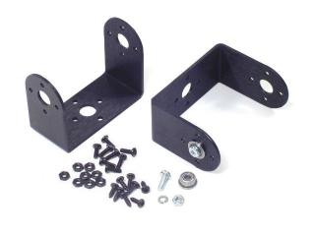
Aluminum “C” Servo Bracket with Ball Bearing ASB-09
http://www.lynxmotion.com/p-400-aluminum-c-servo-bracket-with-ball-bearings-two-pack.aspx
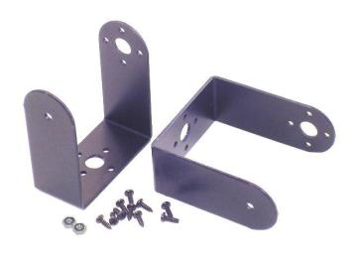
Aluminum Long “C” Servo Bracket ASB-05
http://www.lynxmotion.com/p-326-aluminum-long-c-servo-bracket-two-pack.aspx
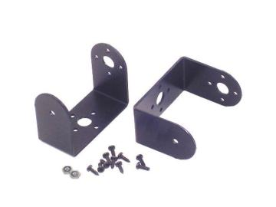
Aluminum “C” Servo Bracket ASB-03
http://www.lynxmotion.com/p-278-aluminum-c-servo-bracket-two-pack.aspx

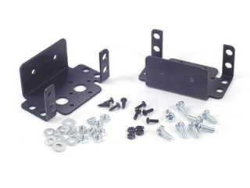
Aluminum Multi-Purpose Servo Bracket, ASB-04
http://www.lynxmotion.com/p-286-aluminum-multi-purpose-servo-bracket-two-pack.aspx
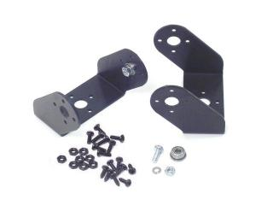
Aluminum Offset Servo Bracket with Ball Bearings, ASB-11
http://www.lynxmotion.com/p-402-aluminum-offset-servo-bracket-with-ball-bearings-two-pack.aspx
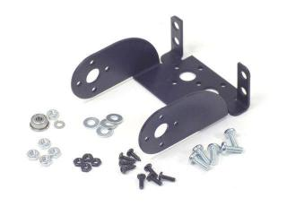
Aluminum Servo Offset Axis Bracket, ASB-16
http://www.lynxmotion.com/p-542-aluminum-servo-offset-axis-bracket-single-pack.aspx
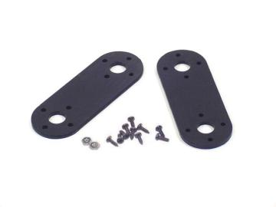
Aluminum Interconnect Bracket, ASB-18
http://www.lynxmotion.com/p-479-aluminum-interconnect-bracket-two-pack.aspx
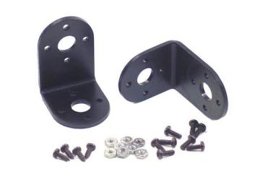
Aluminum “L” Connector Bracket,ASB-06
http://www.lynxmotion.com/p-328-aluminum-l-connector-bracket-two-pack.aspx
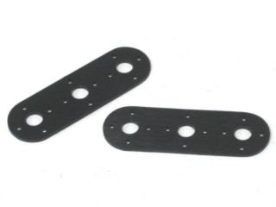
Aluminum Joining Bracket – 3”, ASB-25
http://www.lynxmotion.com/p-732-aluminum-joining-bracket-3-two-pack.aspx
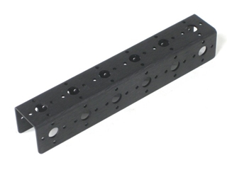
Aluminum Channel – 6”, ASB-506
http://www.lynxmotion.com/p-754-aluminum-channel-6-single-pack.aspx
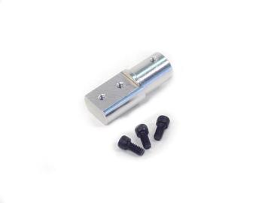
Aluminum Tubing Option Connector Hub, HUB-09
http://www.lynxmotion.com/p-494-aluminum-tubing-option-connector-hub-single.aspx
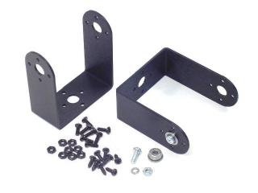
Aluminum Long “C” Servo Bracket with Ball Bearings, ASB-10
http://www.lynxmotion.com/p-401-aluminum-long-c-servo-bracket-with-ball-bearings-two-pack.aspx
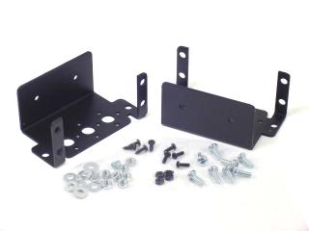
Aluminum Multi-Purpose 755HB/MG Servo Bracket, ASB-201
http://www.lynxmotion.com/p-635-aluminum-multi-purpose-755hbmg-servo-bracket-two-pack.aspx
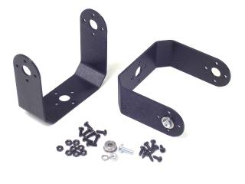
Aluminum “C” 755HB/MG Servo Bracket, ASB-202
http://www.lynxmotion.com/p-644-aluminum-c-755hbmg-servo-bracket-two-pack.aspx
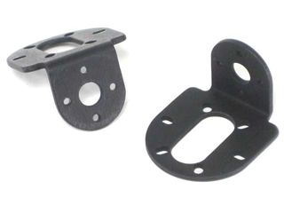
SES Aluminum Motor Mount, MMT-04
http://www.lynxmotion.com/p-842-ses-aluminum-motor-mount-pair.aspx
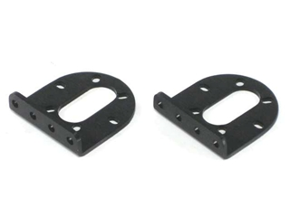
Aluminum Motor Mount, MMT-02
http://www.lynxmotion.com/p-104-aluminum-motor-mount-pair.aspx
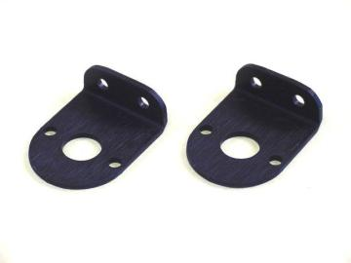
Potentiometer Mounting Bracket, PMT-01
http://www.lynxmotion.com/p-781-potentiometer-mounting-bracket-pair.aspx
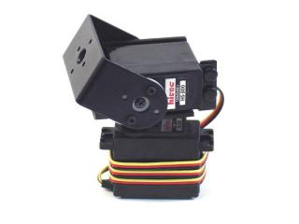
LynxB – Pan and Tilt Kit, BPT-KT
http://www.lynxmotion.com/p-287-lynx-b-pan-and-tilt-kit-black-anodized.aspx
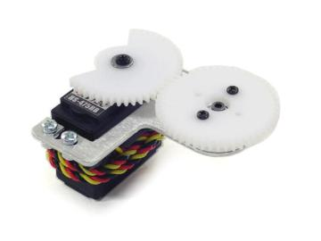
Low Profile Axis, LPA-01
http://www.lynxmotion.com/p-481-low-profile-axis-no-servos.aspx
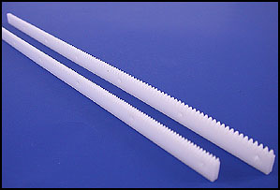
48 Pitch Gear Rack, 48P-125-12
http://www.servocity.com/html/gear_racks.html
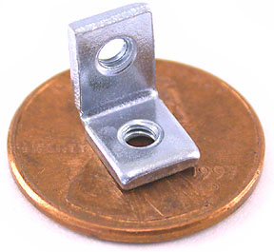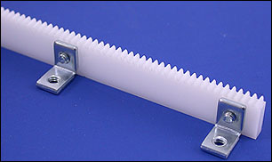
Mini Bracket, 534-621
http://www.servocity.com/html/534-621_bracket.html
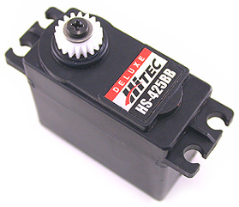
48 Pitch Hitec Servo Gears, 18, 32 and 48 teeth, RSA48-2HS-18, RSA48-2HS-32, RSA48-2HS-48
http://www.servocity.com/html/48_pitch_hitec_servo_gears.html
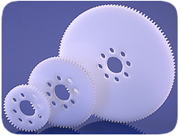
48 Pitch Hub Gears 52 and 76 Teeth, RHA48-26-52, RHA-26-76
http://www.servocity.com/html/48_pitch_acetal_hub_gears__1_8.html
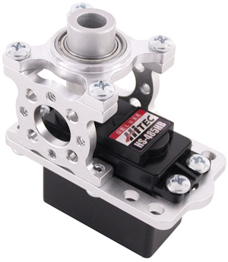
Hitec ServoBlocks (Plain Shaft), SB609SH
http://www.servocity.com/html/hitec_servoblocks__plain_shaft.html
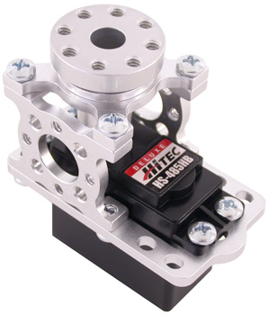
Standard Hitec ServoBlocks, SB608SH
http://www.servocity.com/html/standard_hitec_servoblocks.html
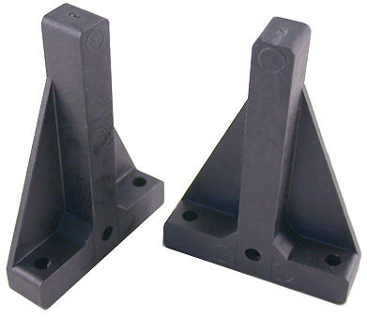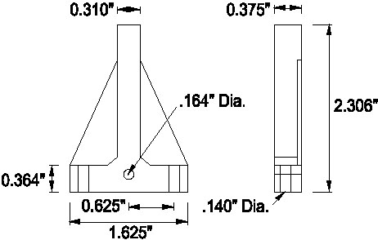
Servo Mount, G402
http://www.servocity.com/html/g402_servo_mount.html
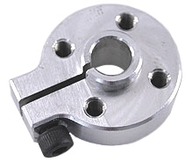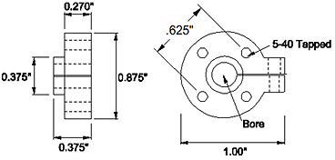
0.625” Aluminum Clamping Hubs .25” and 6mm, 3162CH, 3128CH
http://www.servocity.com/html/clamping_hubs.html
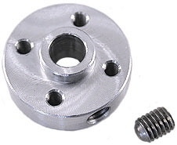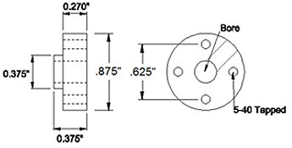
0.625” Set Screw Hubs .125”, .25”, 6mm, 3455H, 3463H, 3472H
http://www.servocity.com/html/set_screw_hubs.html
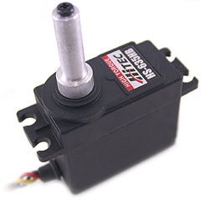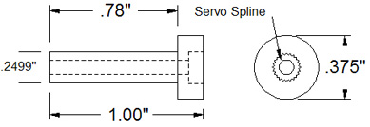
Servo Shaft Attachment .25”, 250HS
http://www.servocity.com/html/servo_shaft_attachment___250__.html
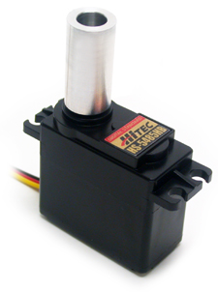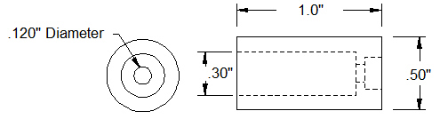
Servo Shaft Attachment, .5”, 525128
http://www.servocity.com/html/servo_shaft_attachment___500__.html
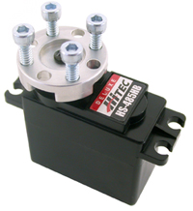
Standard Hub Horn, We have an older version but about the same, 525130
http://www.servocity.com/html/standard_hub_horn.html
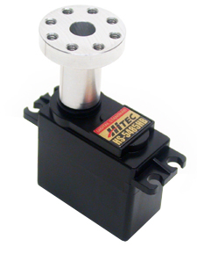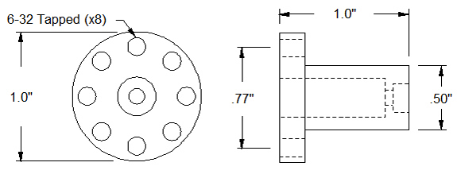
Servo Shaft Hub .5”, 525122
http://www.servocity.com/html/servo_shaft_hub___500__.html
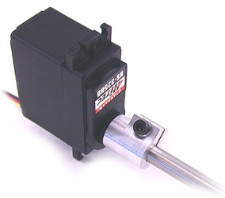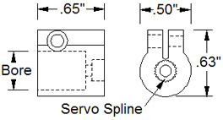
Servo to Shaft Couplers, HSA250
http://www.servocity.com/html/servo_to_shaft_couplers.html
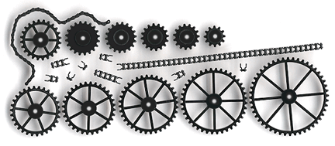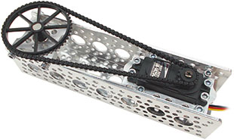
Sprockets and Plastic Chain, C1227 and Many Sprocket sizes
http://www.servocity.com/html/servo_sprockets___1227_.html
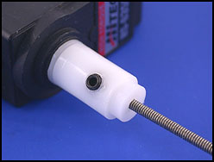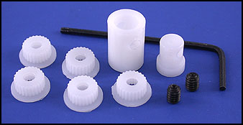
Servo Rotary Driver, SR500
http://www.servocity.com/html/servo_rotary_driver.html
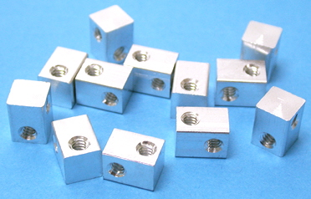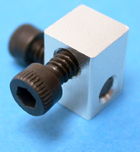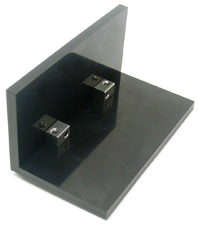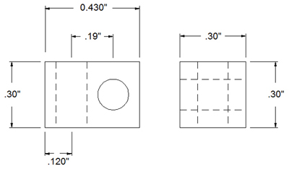
Attachment Blocks, 585400
http://www.servocity.com/html/attachment_blocks.html
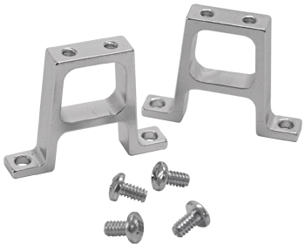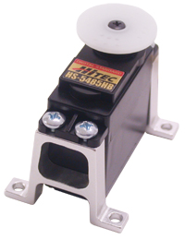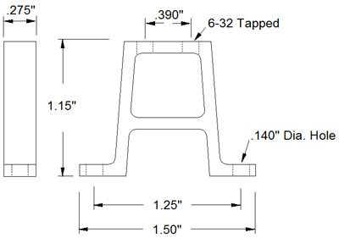
Vertical Aluminum Mount, SVM275-115
http://www.servocity.com/html/vertical_aluminum_mount.html
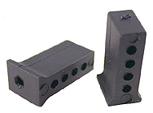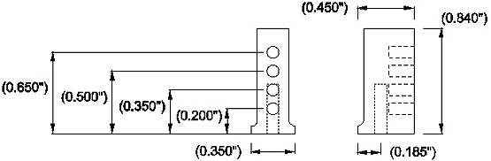
90 Degree Universal, BTR-7006
http://www.servocity.com/html/90_degree_universal.html

